**SMART VEHICLE SYSTEM USING ADVANCED SENSORS AND NAVIGATION  
A PROJECT REPORT**

Submitted by

**ALFI JAMES (23BAI017)**

**NITHYAA SRI .S (23BAI024)**

**SWATHI. A (23BAI016)**

In partial fulfillment of the requirement for the award of the Degree of

**BACHELOR OF COMPUTER SCIENCE WITH ARTIFICIAL INTELLIGENCE**

**UNIVERSITY OF MADRAS**

Under the guidance of

**DR.G.MONIKA M.SC (PH.D.) HEAD OF DEPARTMENT**



**JEPPIAAR COLLEGE OF ARTS AND SCIENCE**

**Padur, Chennai - 603103**

**2023-2024**

**DECLARATION**

We, **ALFI JAMES (23BAI017), NITHYAA SRI .S (23BAI024)** and **SWATHI. A (23BAI016)** of I B.Sc.CS [AI], at this moment, declares that this project report on ***“Smart vehicle system using advanced sensors and navigation”*** submitted to the University of Madras in partial fulfillment of the requirement for the award of the Degree of Bachelor of Computer Science with Artificial Intelligence, under the guidance of **DR.G.MONIKA M.SC (Ph.D.) HEAD OF DEPARTMENT** has not been submitted earlier to any other university or institute for the award of any degree

**(ALFI JAMES)**

**(NITHYAA SRI. S)**

**(SWATHI. A)**

**Place:**

**Date:**

**BONAFIDE CERTIFICATE**

This is to certify that the project titled “**Smart vehicle system using advanced sensors and navigation**”is the bonafide work done by **Alfi James (23BAI017), Nithyaa Sri. S (23BAI024),** and **Swathi.S (23BAI016)** Year studentof Jeppiaar College of Arts and Science, Padur, Chennai in partial fulfillment of the requirement for the award of the Degree of Bachelor of Computer Science with Artificial Intelligence**,** during the academic year 2023-2024

**PROJECT GUIDE**

**HEAD OF THE DEPARTMENT**

**Date:**

**VIVA VOCE EXAMINATION**

This viva voce examination of the project titled “**Smart vehicle system using advanced sensors and navigation**”, is submittedby **Alfi James (23BAI017), Nithyaa Sri .S (23BAI024),** and **Swathi. S (23BAI016),** of I B.Sc. CS [AI].

University of Madras Examination held on ___________________

**INTERNAL EXAMINER EXTERNAL EXAMINER**

**ACKNOWLEDGEMENT**

We would like to express our sincere thanks to our beloved Chairperson Dr. Regeena J. Murli and our Director Mr. Murli S for motivating us in all our endeavours.

We wish to thank Dr. Lavanya L, Principal, Jeppiaar College of Arts and Science, for the help and moral support extended to us.

Our profound thanks to Dr. Monika. G Head of the Department of computer science and Application, Jeppiaar College of Arts and Science for her encouragement and valuable support throughout this project.

Our deep sense of gratitude to Dr. Monika. G Head of the Department of computer science and Application, Jeppiaar College of Arts and Science, for imparting his knowledge and guidance as our project guide, which enabled us to complete the project work on time.

**Alfi James**

**Nithyaa Sri. S**

**Swathi. A**

**CONTENTS**

|  |  |  |
| --- | --- | --- |
| **Chapter No.** | **Particulars** | **Page No.** |
| **I** | **Introduction** | **2** |
| **II** | **Problem Identification:** | **2** |
| **III** | **Review of Existing work** | **3** |
| **IV** | **New Features** | **4** |
| **V** | **Outcome** | **4** |
|  | **Conclusion:** | **5** |
|  | **References:** | **5** |

ABSTRACT

This project is all about making riding bikes easier and safer. We're building a system that uses digital maps and predicts traffic in real time, just like how Google Maps does it. Picture having a map on a screen with a friendly voice guiding you, all without needing to touch anything while you ride. Our goal is simple: to find you the quickest and safest routes possible, making your ride hassle-free and enjoyable. This project aims to change the way people ride bikes in cities, making it faster and safer for everyone.

1. INTRODUCTION:

In today's busy cities, getting around on a two-wheeler can be tricky. We often get stuck in traffic or take the wrong turns, making our rides stressful. That's why we're working on something exciting: a special navigation system just for two-wheelers. Our system uses digital maps and real-time traffic updates, like the ones you see on Google Maps. Imagine having a screen on your bike that shows you the best routes, and a friendly voice guiding you along the way, all without you having to touch anything while you ride. This introduction sets the stage for our project, where we'll explore how this smart navigation system can make riding bikes in cities easier and safer for everyone.

1. PROBLEM IDENTIFICATION:

* Lack of time due to traffic and accidents on the route makes it difficult to reach work or college on time while traveling on two-wheelers.
* Dependence on the pillion rider for directions disrupts both the rider and other road users, as the rider frequently needs to ask for help while navigating.
* Relying solely on phone maps for navigation leads to distractions and increases the risk of accidents, as riders may not pay enough attention to the road while checking directions.

2

1. REVIEW OF EXISTING WORK :

**TVS NTORQ 125:**

The NTORQ 125 impresses with its advanced Bluetooth integration, offering a plethora of connected features aimed at enhancing the riding experience. Navigation assist, last-parked location tracking, voice assistance, tripper functionality, clock display, and low battery indication contribute to a comprehensive suite of tools for riders. These features, combined with the NTORQ's sporty performance, make it a standout choice for tech-savvy riders.

**TVS Jupiter:**

While not as feature-rich as its sibling, the Jupiter also offers Bluetooth connectivity, albeit with more limited functionality. Riders can still benefit from navigation assistance and call alerts, adding convenience to their journeys. With its focus on comfort and practicality, the Jupiter remains a reliable option for urban commuting.

**Suzuki Access 125:**

The Access 125 joins the Bluetooth-connected trend with its own set of features aimed at keeping riders informed on the go. Navigation assistance and call alerts ensure riders stay connected without compromising safety. Coupled with the Access 125's refined performance and comfortable ride quality, these features enhance the overall riding experience.

**Royal Enfield Hunter 350 (anticipated):**

While details are scarce, the anticipation surrounding the Hunter 350 suggests it will also embrace Bluetooth connectivity, aligning with modern expectations. With rumors of navigation assistance and voice guidance, the Hunter 350 aims to combine classic charm with contemporary convenience, appealing to riders seeking a timeless yet tech-savvy motorcycle experience.

**3**

**4. NEW FEATURES**:

Displaying

* + Digital map
  + Clock with date and time
  + Digital speed meter
  + Voice Recognition
  + GPS
  + Water resistance
  + Day and Night mode
  + Making the short route in case of traffic and accidents in the route helps mainly with delivery
  + Storing personal locations like home and work

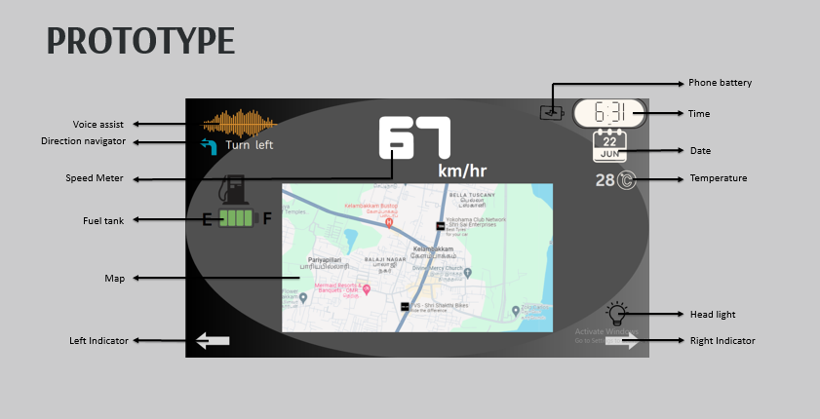 5. OUTCOME:

4

PROTOTYPE EXPLANATION:

This prototype is connected by the phone Bluetooth to the two-wheeler's front screen. This screen was made by waterproof. It has some new features like voice recognition symbols to move left, right , straight, or turn, a fuel tank, the map shown in between the screen and the kilometer shown in numbers, and the phone battery symbol, time ,date, and current weather. The headlight and left or right indicator have been shown.

CONCLUSION:

In summary, the implementation of Bluetooth-connected smart features in motorcycles and scooters promises to save time and enhance convenience for riders. With leading car manufacturers like Tata, Mahindra, Hyundai, and Toyota also adopting similar navigation systems, the technology's impact extends beyond two-wheelers. As these advancements continue, the future of transportation appears more connected, efficient, and user-friendly for all road users.

REFERENCES:

[www.bikedekho.com](http://www.bikedekho.com)

[www.researchgate.net](http://www.researchgate.net)

[www.google.com](http://www.google.com)

**5**